Amrutrh sagar Vemuganti
2403a51l44
B-52

Lab 4
Advanced Prompt Engineering – Zero-shot, One-shot, and Few-shot Techniques
Task Description-1: Zero-shot Prompting
Prompt: Write a Python function to determine whether a given number is prime.
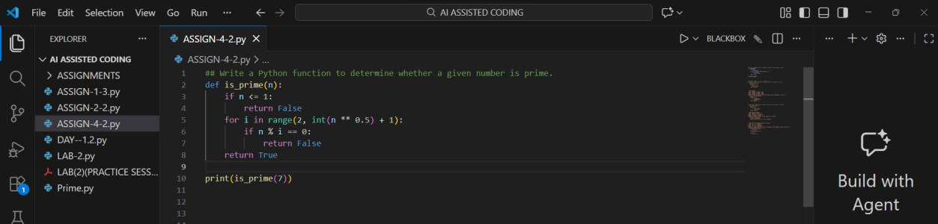
OUTPUT:
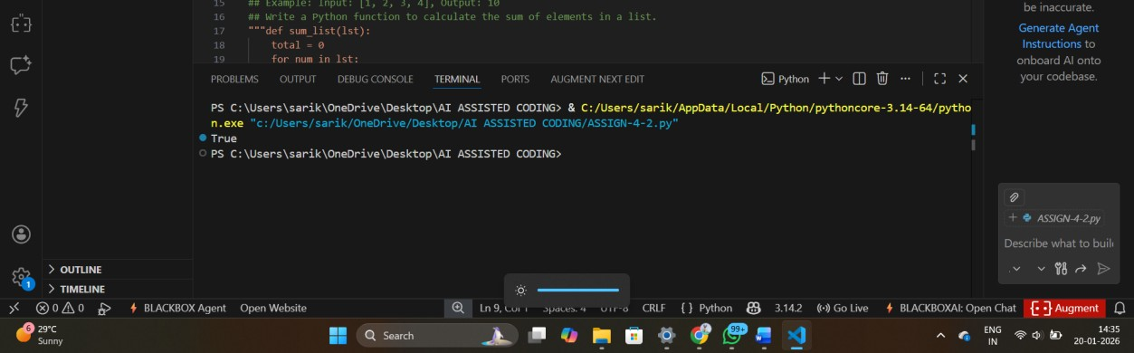
Explanation:
- Zero-shot prompting provides only instructions, no examples.
- The AI correctly implemented:
Prime definition logic
Square-root optimization
- Demonstrates that simple logical problems work well with zero-shot prompts.
Task Description-2: One-shot Prompting
Prompt: Write a Python function to calculate the sum of elements in a list.
Example: Input: [1, 2, 3, 4], Output: 10
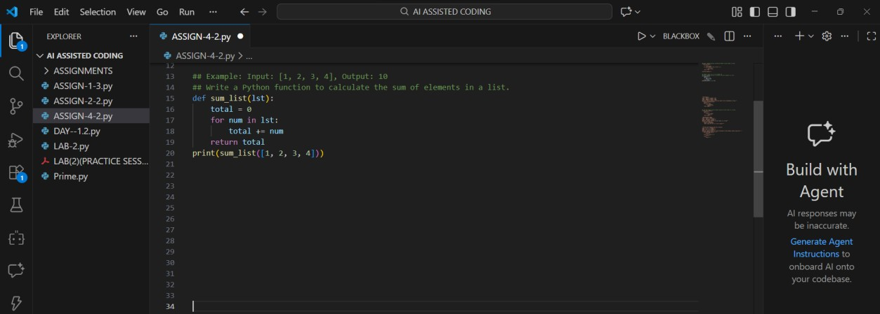
OUTPUT:
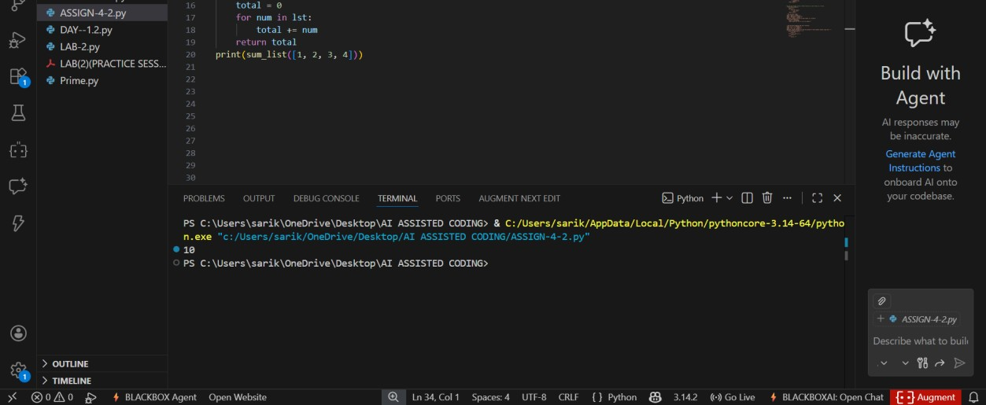
Explanation:
- One example clarifies the expected behavior.
- The AI correctly inferred:
Iteration over list
Accumulation of sum
- The example helped remove ambiguity.

Task Description-3: Few-shot Prompting
Prompt: Write a Python function to extract digits from an alphanumeric string.
Examples:
Input: "abc123" → Output: "123"
Input: "a1b2c3" → Output: "123"
Input: "2024AI" → Output: "2024"
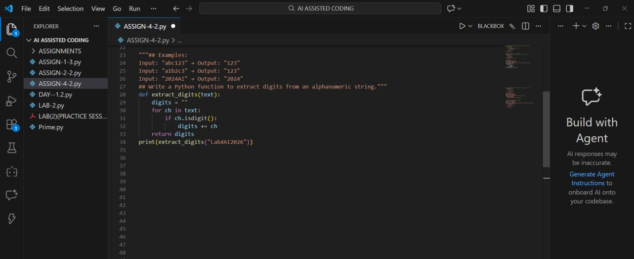
OUTPUT:
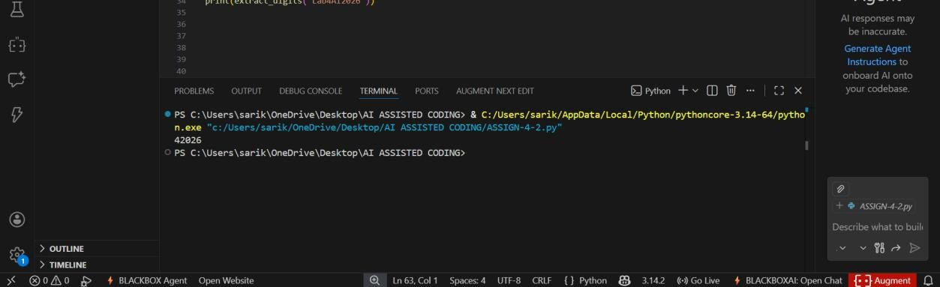
Explanation:
- Few-shot prompting provides pattern recognition.
- AI correctly:
Identified digit extraction rule
Ignored alphabetic characters
- Output accuracy improved due to multiple examples.

Task Description-4: Comparison Zero-shot vs Few-shot Prompting
Zero-shot Prompt: Write a Python function to count vowels in a string.
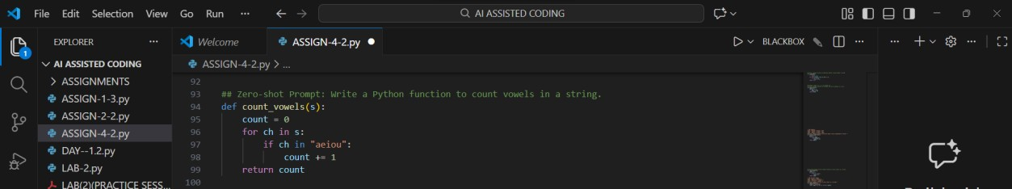
Few-shot Prompt: Write a Python function to count vowels in a string
Examples:
Input: "hello" → Output: 2
Input: "Education" → Output: 5
Input: "AI Tools" → Output: 4
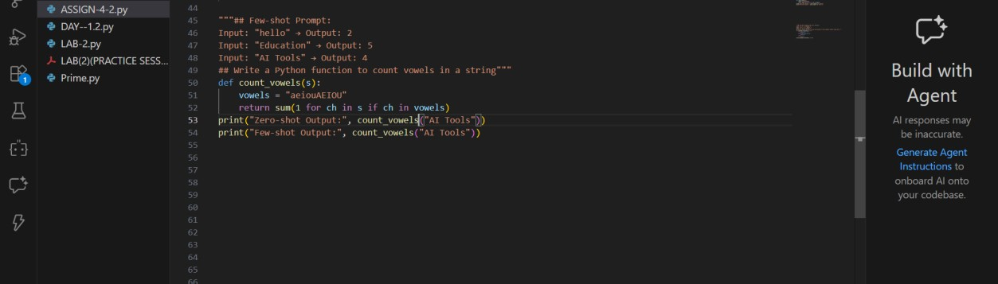
OUTPUT:
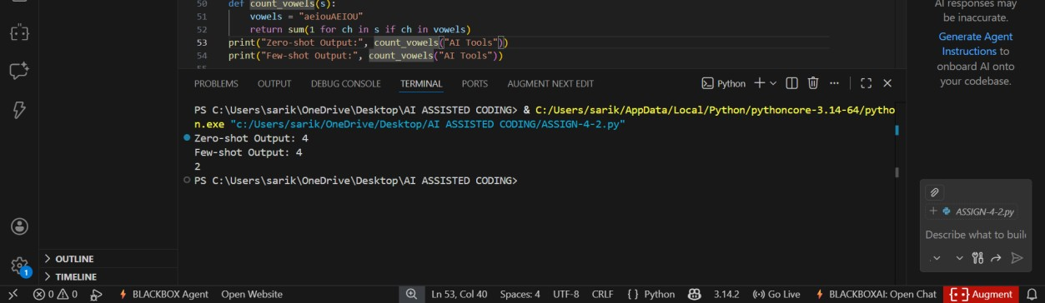
Comparison Table:
Feature | Zero-shot | Few-shot
Case handling | Only lowercase | Upper & lowercase
Accuracy | Moderate | High
Robustness | Basic | Improved
Readability | Simple | Optimized

Explanation:
1. Few-shot prompting improved the output by providing examples that showed:
Upper and lowercase handling
Realistic input patterns
This helped the AI generate a more accurate and generalized solution.
Task Description-5: Few-shot Prompting (No min() function)
Prompt: Write a Python function to find the minimum of three numbers without using min().
Examples:
Input: (3, 5, 1) → Output: 1
Input: (10, 2, 7) → Output: 2
Input: (4, 4, 9) → Output: 4
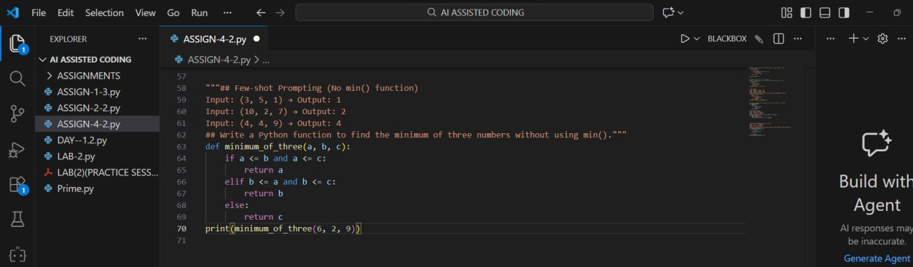
OUTPUT:
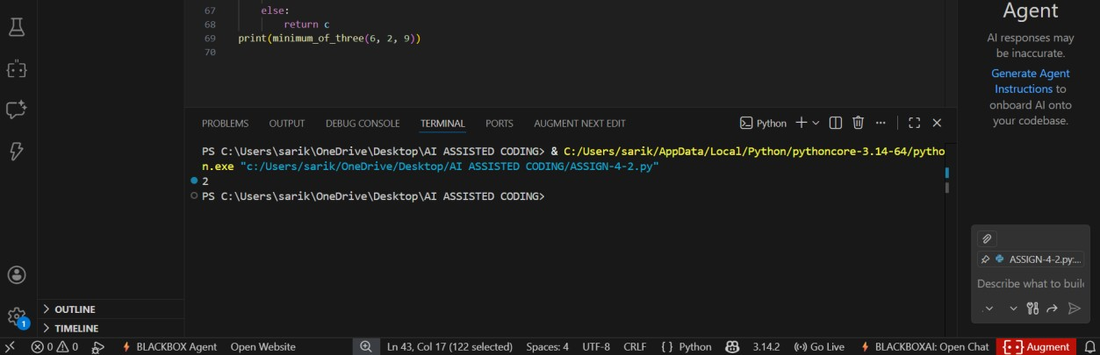
Explanation:
- Few-shot examples guided logical comparisons.
- Handles:
Equal values
All ordering cases
- Does not use built-in min() as instructed.

